# **Deploy docker to ecs**

### **ECS - Elastic Container Service**

Amazon Elastic Container Service (ECS) is a cloud computing service in Amazon Web Services (AWS) that manages containers and lets developers run applications in the cloud without having to configure an environment for the code to run in. It enables developers with AWS accounts to deploy and manage scalable applications that run on groups of servers called clusters through API calls and task definitions.

### **ECR - Elastic container repository**

Amazon Elastic Container Registry (Amazon ECR) is an AWS managed container image registry service that is secure, scalable, and reliable. Amazon ECR supports private repositories with resource-based permissions using AWS IAM.

This is where we will store our docker image, and all other services will retrieve the resources and docker images from here itself.

To create an image repository

A repository is where you store your Docker or Open Container Initiative (OCI) images in Amazon ECR. Each time you push or pull an image from Amazon ECR, you specify the repository and the registry location which informs where to push the image to or where to pull it from.

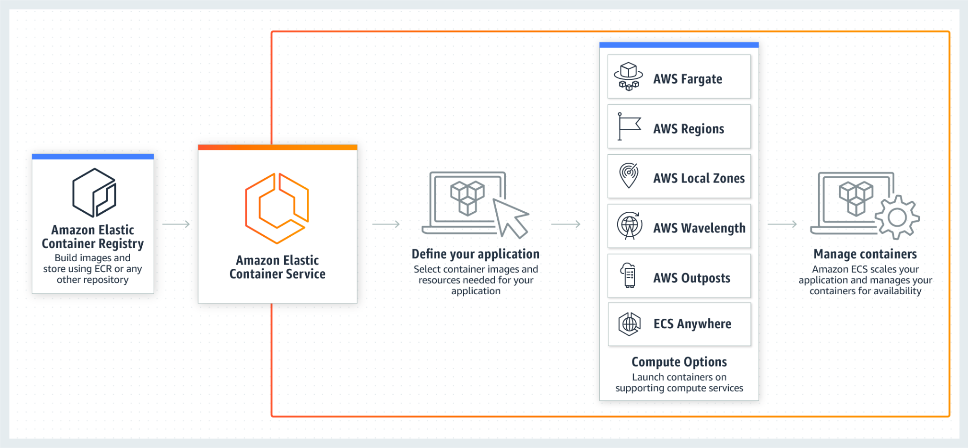

### **AWS Fargate**

AWS Fargate is a serverless, pay-as-you-go compute engine that lets you focus on building applications without managing servers, it ia a serverless compute for containers, which eliminates the need to configure and manage control plane, nodes, and instances.

## **Steps to deploy to ECS**

* Build the docker image locally
  + Build the docker from the flask app or anything you want to host after all testing locally
* Install AWS CLI
  + use the AWS command line tools to issue commands at your system's command line to perform Amazon ECR and other AWS tasks.
* Create an ECR repository
  + A repository is where you store your Docker or Open Container Initiative (OCI) images in Amazon ECR. Each time you push or pull an image from Amazon ECR, you specify the repository and the registry location which informs where to push the image to or where to pull it from.
* Push Docker Image to ECR
  + Build, tag, and push a Docker image
  + You use the Docker CLI to tag an existing local image and then push the tagged image to your Amazon ECR registry.

Select the repository you created and choose View push commands to view the steps to push an image to your new repository.

* + Run the login command that authenticates your Docker client to your registry by using the command from the console in a terminal window. This command provides an authorization token that is valid for 12 hours.
* Create a Fargate cluster
* Create an ECS Task
* Run the task definition
* Setup the ECS service